WANDERING SOULS

**What you need:**

* Two Player tokens
* 6 Enemy tokens
* 5 friendly tokens
* 5 gift cards
* One 10-sided dice
* One 6-sided dice

**Objective**

The goal of the game is to rescue as many friendly spirits as possible. The player who has rescued the most friendlies wins.

**Instructions**

Place both players at start, whichever player is older goes first. Then roll a 10-sided dice to determine how many steps to take. A player may move to any spot if it is connected by a line to their current spot. Friendly, enemy, and destination icons count as a spot.

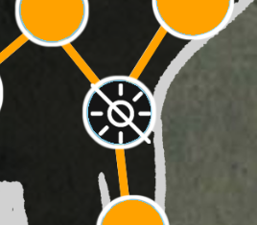_______________________________________

**Mana drain:** Throughout the map there are areas where your ability to cast light is diminished. On start flip your token to the light side up, when you pass a mana drain spot, you must flip your token to the dark side.

_______________________________________

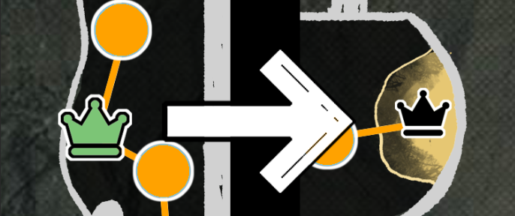**Friendly interactions:** Once you land on a friendly spot, place the friendly token on top of your player token. You are now escorting this friendly. Notice the symbol on the friendly token, you must match it with the icon on the board. Once escorted to the proper symbol, you may place the friendly chip in your rescue area. You may escort up to two friendlies at a time.

_______________________________________

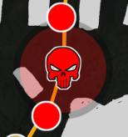**Enemy interactions:** Once on a red dot, STOP, you have initiated battle with an enemy.

IF YOU HAVE LIGHT: Roll a 6-sided dice to determine if you may move forward. 3 and below means you may not move forward, anything above 3 means you may advance.

IF YOU HAVE NO LIGHT: Roll a 6-sided dice, 4 and below means you may not move forward, anything above a 4 means you may advance.

Once you pass the enemy, flip its chip to dead.

BE AWARE: Enemies regenerate, once the player leaves the final red dot of battle, flip the enemy back to alive.

IF YOU ARE ESCORTING: If you have initiated battle while escorting a player, be aware, if you roll exactly 1 the friendly is badly wounded and returns to their original icon.

_______________________________________

**Gift cards:** Once you have successfully brought a friendly to their matching icon, you receive the card that was on their spot.

**Banishing Crystal Gift:** This gift is a small quartz like stone that is remarkably cold and lightweight. It is used to capture souls. You may use this on enemy squares to remove an enemy permanently. Banished enemies will never regenerate. You may use this when in battle range of an enemy.

**Mana Potion Gift:** This gift is a small round glass flask that swirls with a cyan liquid with suspended gold flakes inside. This potion refills your ability to cast light entirely. You may use it whenever.